**SL Unit 4** **– Problem Solving**  
Quiz 2

|  |  |  |  |
| --- | --- | --- | --- |
| **Question 1** | | | |
| Objectives: | 4.1.18 | Exam Reference: | May-14 11 |

Explain why an object is an example of abstraction. [2]

*Award up to* ***[2 marks max]***.

An object hides the details;

Yet preserves the functionality;

**OR**

Objects combine abstractions of data and code;

While hiding away implementation of details;

|  |  |  |  |
| --- | --- | --- | --- |
| **Question 2** | | | |
| Objectives: | 4.2.5 | Exam Reference: | Nov-15 6 |

A sub-program all_even() accepts a positive integer N and outputs true if all digits of N are even, otherwise it outputs false. For example, all_even(246) outputs true and all_even(256) outputs false.

The following algorithm is constructed for the sub-program all_even(N).

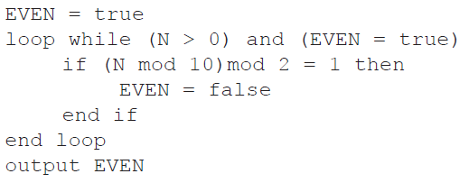

1. Explain why this algorithm does not obtain the correct result. [2]

*Award up to* ***[2 max]***.

The value of N is never changed;

So the logical expression in the while loop always evaluates to true;

And loop repeats an infinite number of times;

1. Outline what should be changed in the algorithm to obtain the correct result. [3]

Statement N = N div 10;

Should be written within the while loop;

After the if statement;

|  |  |  |  |
| --- | --- | --- | --- |
| **Question 3** | | | |
| Objectives: | 4.2.1, 4.2.3, 4.2.6 | Exam Reference: | Nov-15 9 |

1. A candy company manufactures 20 different kinds of candy, each identified by a product ID.

An array, Product_ID, is used to store the product IDs, and another array, Unit_Price, is

used to store the price per unit of each type of candy. The unit price of the product identified

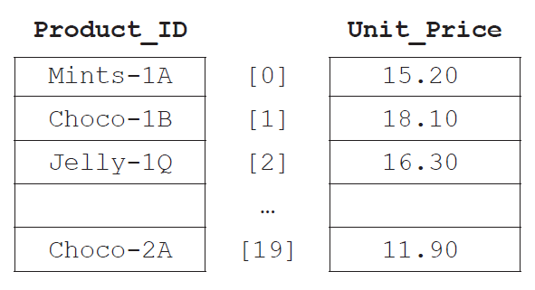by Product_ID[N] is equal to Unit_Price[N] for any index N.

1. State the price of the candy identified by Product_ID[2]. [1]

16.30;

1. Explain the steps that would be needed in an algorithm to calculate the average unit

price. [3]

Set a variable (sum) to zero;

Loop through the array Unit_Price;

Add each array element to variable sum;

Divide sum by 20;

1. Construct the algorithm that will output the price of a candy after its product ID is

entered by the user. The algorithm should output an appropriate message if the

product ID entered does not appear in the array Product_ID. [6]

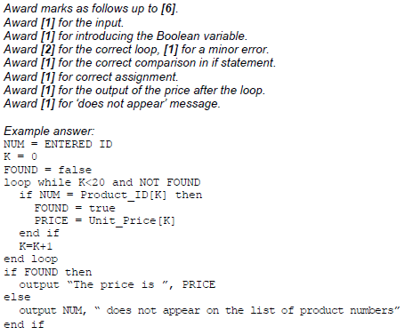

The company maintains two warehouses each of which stocks a selection of the 20 types of  
candy indicated above.  
  
The first warehouse stocks 15 items and their IDs are stored in an array, One. The second  
warehouse stocks 10 items and their IDs are stored in an array, Two.

All product IDs common to both warehouses will be placed in an array, Three.

1. (i) State the maximum number of common product IDs which can be placed   
    in Three. [1]  
     
     
     
     
     
     
   (ii) Construct the algorithm that will place all product IDs common to both  
    warehouses in Three. [4]

10

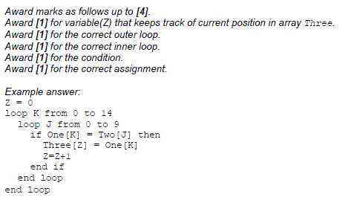

|  |  |  |  |
| --- | --- | --- | --- |
| **Question4** | | | |
| Objectives: | 4.2.1, 4.2.6, 4.2.7 | Exam Reference: | Nov-17 13 |

A character array S holds the word “PSEUDOCODE”.



1. State the index of character “U” in the array S.

3

1. Consider the following algorithm. The function len() returns the number of characters

in an array (for example, len(S) is 10).

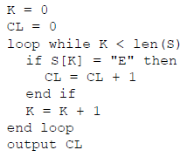

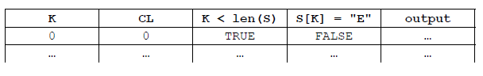 For this algorithm, complete the following trace table. [4]

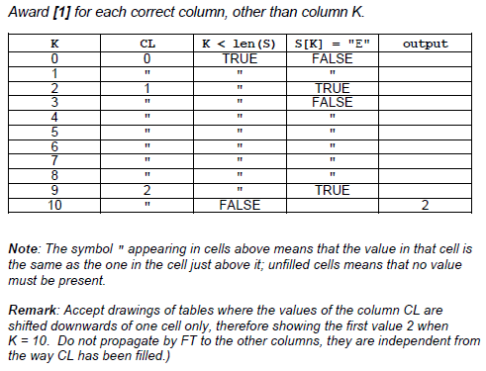

A simple method of encoding a message is to use substitutions to produce a cryptogram.

Given a positive integer N and the array UPCASELETTERS containing letters in alphabetical order, a new array SUBSTITUTE is created by shifting the entire contents of UPCASELETTERS to the left, N times. As an element moves off the left of the array, it moves back into the right side of the array.  
For example, given the array UPCASELETTERS:



When N = 5 the array SUBSTITUTE will be:



1. Construct an algorithm which creates the array SUBSTITUTE. You may assume that a

positive integer N and array UPCASELETTERS are given. [5]

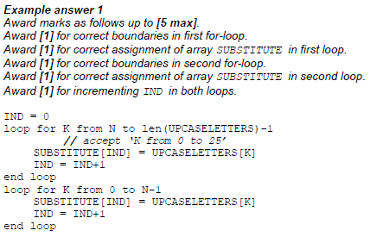

This encoding method produces a cryptogram of a sentence by replacing each uppercase  
letter of the sentence with its substitute. Other characters in the sentence are not changed.

For example, using the arrays shown on page 6:

Input (sentence): ARS LONGA, VITA BREVIS.

Output (cryptogram): FWX QTSLF, ANYF GWJANX.

The following algorithm fragment inputs the characters, one by one, from the input sentence,  
and outputs its cryptogram using the method encode().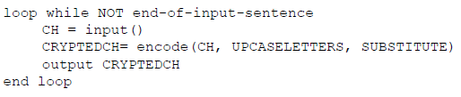



The method encode() accepts a character CH and two arrays UPCASELETTERS and

SUBSTITUTE, as defined above, and returns the corresponding character CRYPTEDCH of the

character CH.

1. Explain the steps to construct an algorithm for the method encode(). [5]

*Award up to* ***[5 max]****.*

Search the array UPCASELETTERS;

Using a linear/sequential or binary search;

Search for the position/index of character CH;

If CH is found in UPCASELETTER;

Return the value stored in the array SUBSTITUTE at this position/index;

Otherwise return CH;